Premraj Prakare Python Test 8
# q1
class IndexError(Exception):
def __init__(self,msg="Index out of range error occurred!"):
self.msg = msg
super().__init__(self.msg)

def check_element(index):
if index > len(l1):
raise IndexError
else:
print(l1[index])

l1 = [12,23,34,45,56,67,78,89,90]
print("This is your list = ",l1)
index = int(input("Enter index to get element: "))
try:
check_element(index)
except IndexError as e:
print("Exception : ",e)

output:
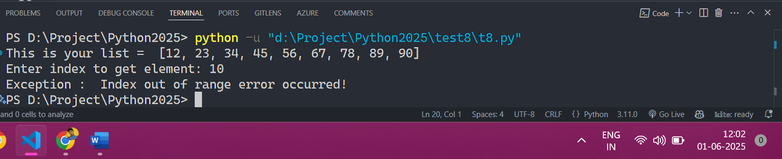
# q2
class CustomError(Exception):
def __init__(self,msg="Negative value error"):
self.msg = msg
super().__init__(self.msg)

def check_positive_numbers(number):
if(number < 0):
raise CustomError
else:
print("You entered positive number =",number)

number = int(input("Enter number : "))

try:
check_positive_numbers(number)
except CustomError as e:
print("Exception : ",e)
output:
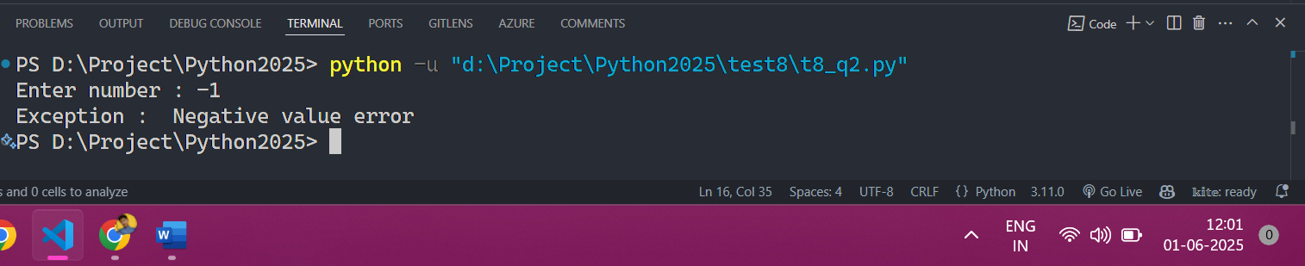
# q3
class WordError(Exception):
def __init__(self, msg="Word Error: Invalid operation."):
self.msg=msg
super().__init__(msg)

def count_words(filename):
if (not filename):
raise WordError
else:
with open(filename, "r") as fp:
data = fp.read()
words = data.split()
print("Total number of words: " + str(len(words)))

filename = input("Enter the filename: ")

try:
count_words(filename)
except (WordError) as e:
print("Exception : ",e)

output:

